FORUM 1 Group 1 Submission

|  |  |  |  |
| --- | --- | --- | --- |
| Juan David  Mejía Ardila | Mayra Patricia  Tejada Osorio | Yinier Arturo  Ramírez Barahona | Ricardo  Peñaloza Velásquez |

*Research Group on Computational Languages. Computing and Decision Sciences Department. Faculty of Mines.*

*Universidad Nacional de Colombia.*

# ACTIVITY 1

Develop the following work products based on the document “Incorporating Emotion Transition Pattern Graph in Metaphor-based Game Design related to Software Engineering”

* A pre-conceptual schema with at least 15 concepts, ten structural relationships, and five dynamic relationships. Such a schema must also have five implications and two events/conditionals. Additionally, you must include ten achievement relationships attached to concepts/dynamic- relationships/structural-relationships. Finally, you must add at least ten elements denoting problems (negations, adverbs, or adjectives). The pre- conceptual schema must be referenced by using a document traceability table with the page/paragraph of the text fragments.

The pre-conceptual schema generated by the activity was figure 1.

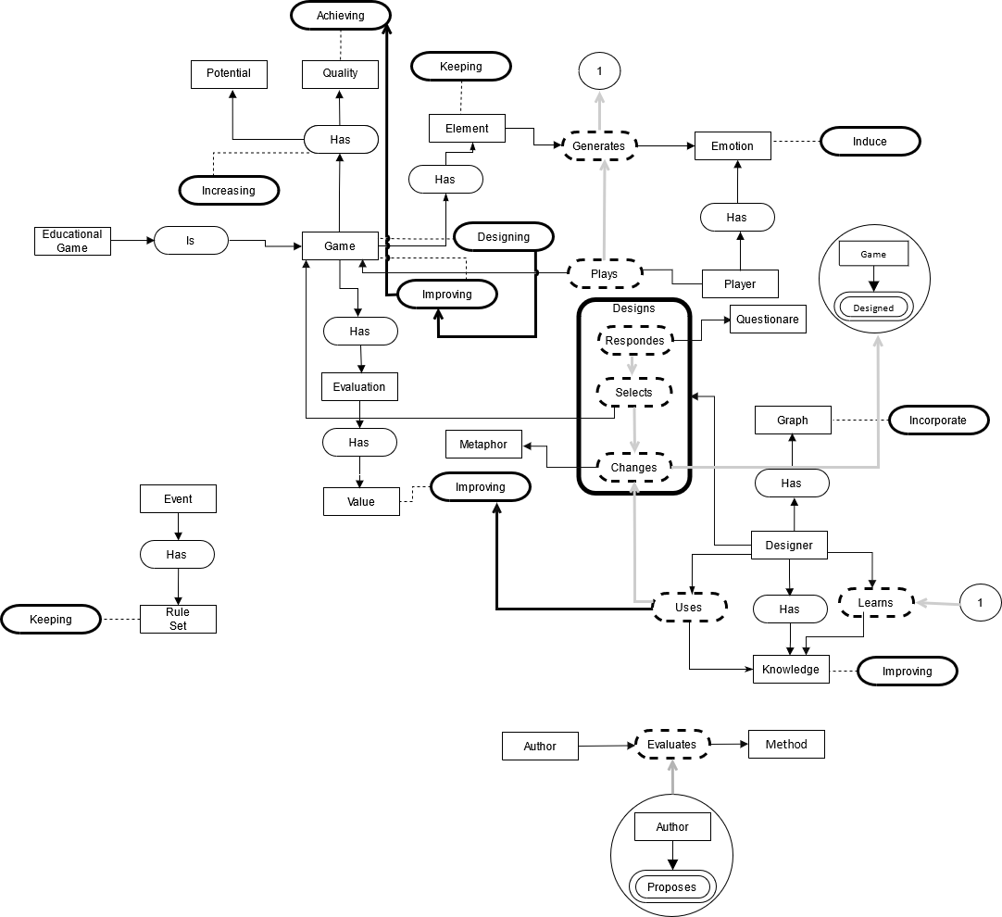

*Figure 1*

* A goal diagram consistent with the pre-conceptual schema by following the rules of the book *UNC- Method revisited.*

The Goal diagram generated is illustrated in figure 2.

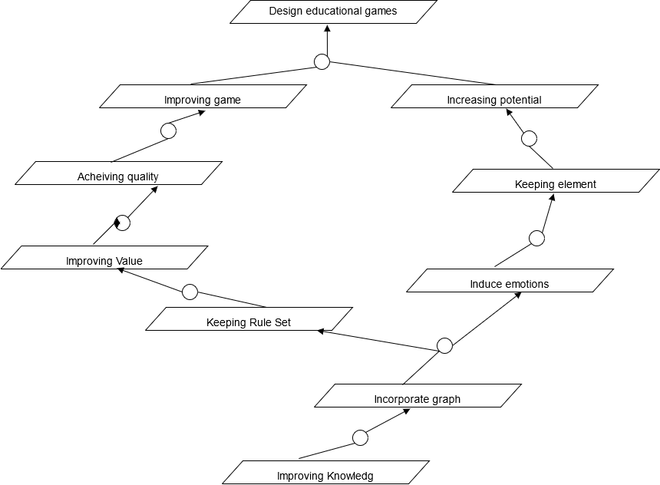

*Figure 2.*

* A cause-and-effect diagram consistent with the pre- conceptual schema by following the rules defined in the Fabio Vargas’ PhD Thesis.

For the cause-and-effect diagram first a problem pre-conceptual schema from the original schema was depicted as a figure 3.

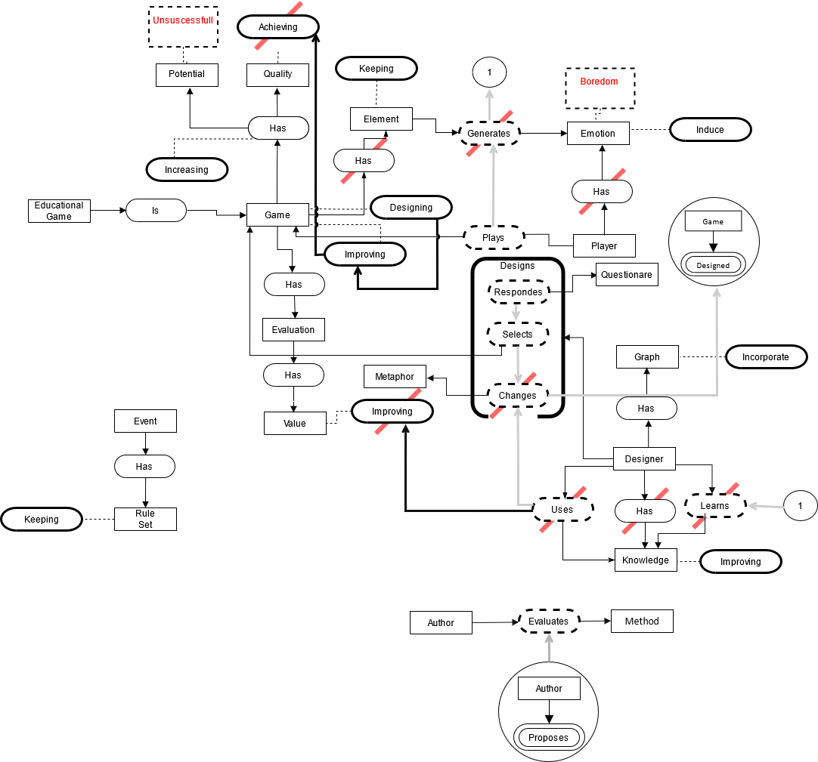

*Figure 3*

Then the following cause-and-effect is the corresponding consistent diagram depicted in Figure 4.

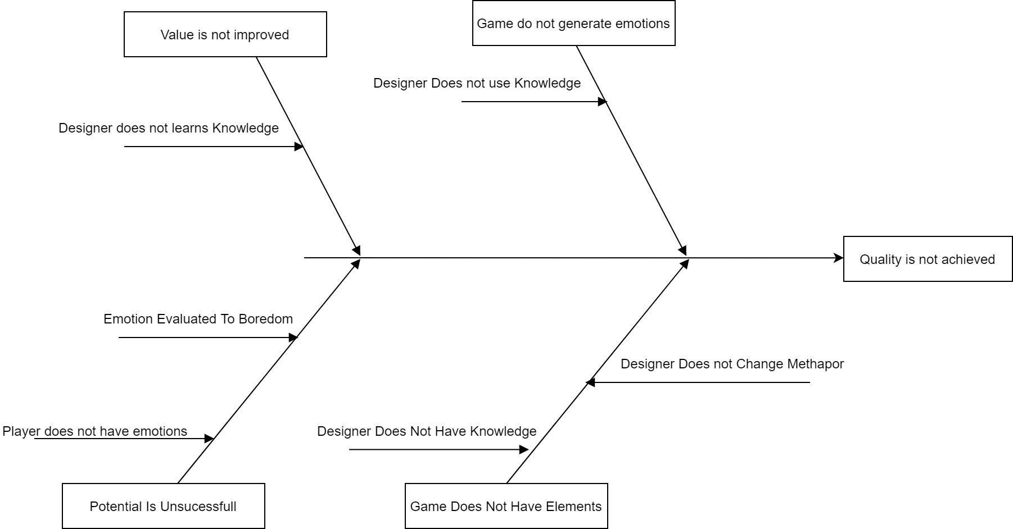

*Figure 4*

# Forum 2

ACTIVITY 1

Select a game from the available list (ask your professor) and then fill in the template for analyzing this kind of games (see Gomez’s MSc Thesis, page 44). Then, identify the original game (*e.g.¸* monopoly, snakes & ladders, poker, etc.) and fill in the same template. After that, identify the metaphor of the game and narrate it as a story. Finally, identify the mechanics of the game.

ACTIVITY 2

Develop the selected game by using Unity®. You need to attach the source code and the executable files. Develop a user guide for the game you developed. Then, you must play the game with the stakeholder in a recorded session (see the document entitled “consentimiento informado,” sign it and send it to the stakeholder at least 48 hours before the recorded session). This session includes a demographic survey of the players. The recorded session must be sent to [gvmatura@unal.edu.co.](mailto:gvmatura@unal.edu.co) The deadline for the recorded session is April 11th.

# REFERENCES

The first document is. Cristina Conati (2002) Probabilistic assessment of user's emotions in educational games, Applied Artificial Intelligence, 16:7-8, 555-575, DOI: [10.1080/08839510290030390](https://doi.org/10.1080/08839510290030390). And the selected fragment with his corresponding entry in the traceability table is *“emotions and engagement during the interaction with educational games. We illustrate how our probabilistic model”* with a resulting diagram of the fragment as is shown in figure 5.

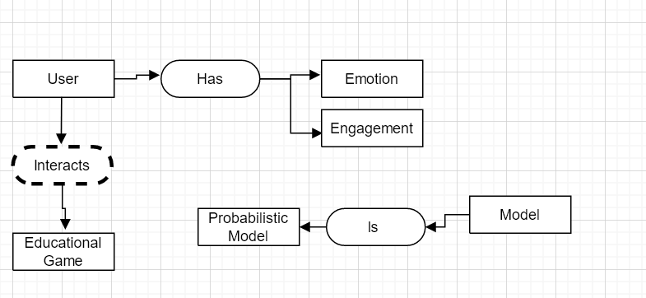

*Figure 5*

As for the Maturanas Phd thesis proposal it was selected the following fragment. “*Emotion transition pattern graph(ETPG) is a visualization model of the player emotions.*” with a corresponding entry in the traceability table and with the pre-conceptual schema as shown in figure 6.

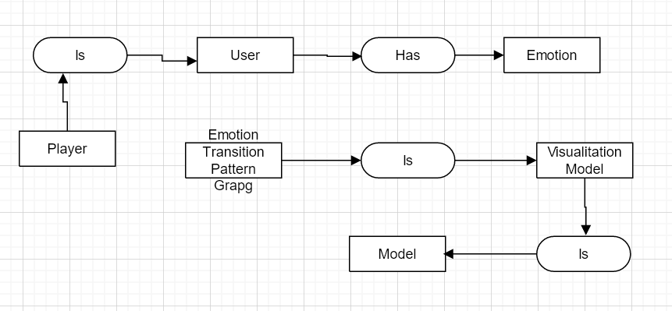

*Figure 6*

For the second document it was selected. Rieber, L. P., & Noah, D. (2008). *Games, simulations, and visual metaphors in education: antagonism between enjoyment and learning. Educational Media International, 45(2), 77–92.* doi:[10.1080/09523980802107096](https://doi.org/10.1080/09523980802107096). And after a careful review the following fragment was selected “*game in tandem with the metaphor resulted in increased levels*

*of tacit learning, as evidenced by greater scores*” with the resulting pre-conceptual schema as in Figure 7 properly documented in the traceability table.

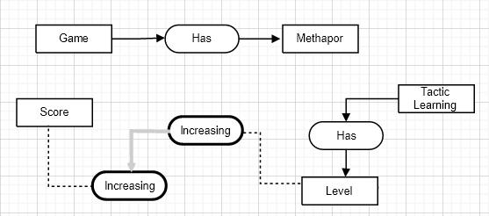

*Figure 7*

This schema then was matched again the following fragment of Grissa’s Phd propors “*values in studies for evaluating games. We propose a method for incorporating emotion transition pattern graph in metaphor-based game*” producing the following Figure 8 pre-conceptual schema properly documented in the traceability table.

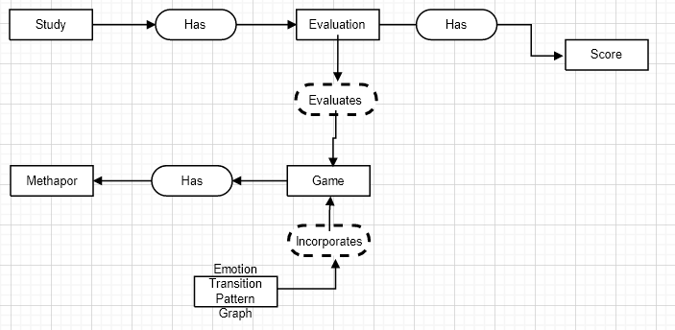

Figure 8